# Introduction to Operating System

So what is a context switch?

As we described in the previous lecture, each instance of an application that we run runs independently from other processes.

Normally they're way more processes than course.

Each process may have one or more threads and all these threads are competing with each other to be executed on the CPU.

Even if we have multiple cores, there are still way more threads than cores, So the operating system will have to run one thread, then stop it, run another thread, stop it.And so on

The act of stopping one thread, scheduling it out, scheduling in another thread and starting it is called a context switch.

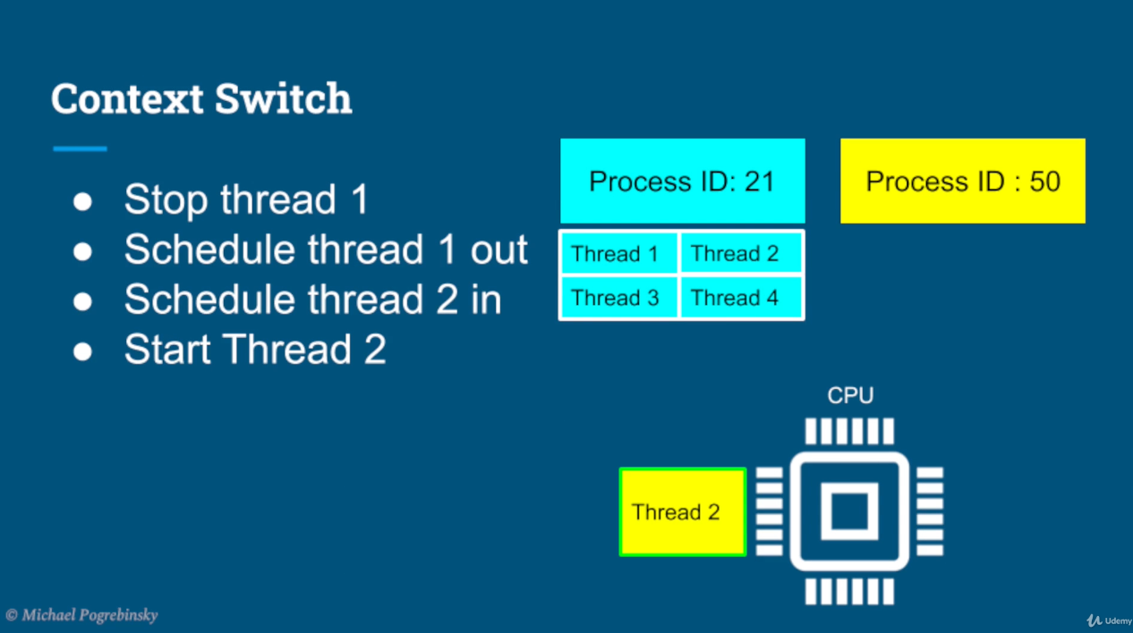

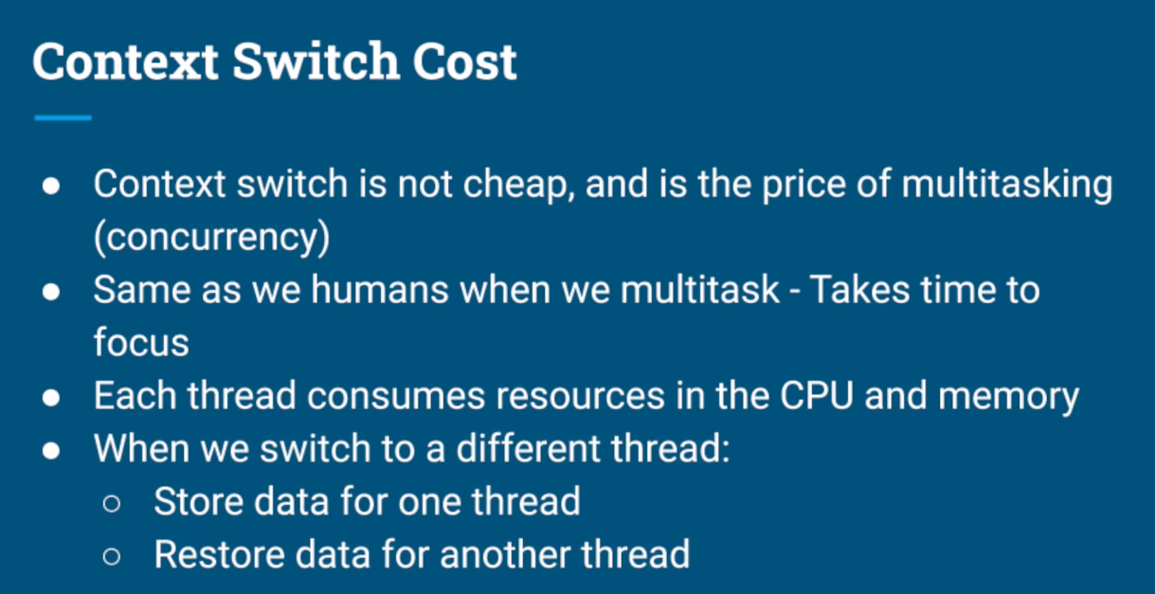

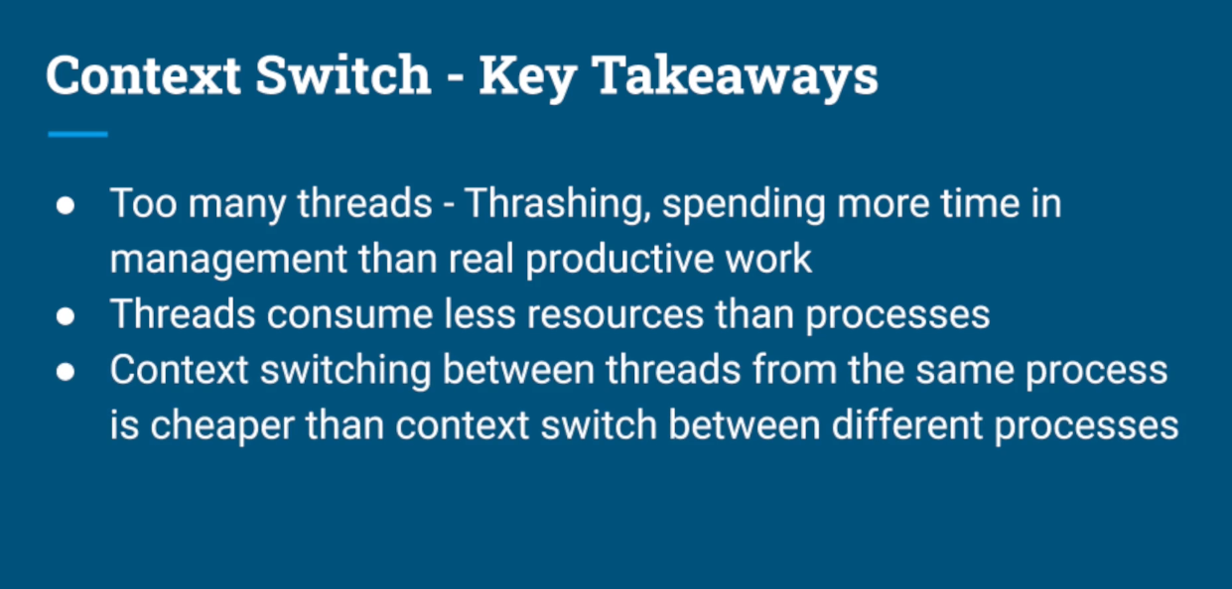

#### How the operating system decides when to run which thread and when to perform a context switch ?

Imagine we're doing a homework using our favorite text editor while listening to our favorite music in the background. So we have two processes, the text editor and the music player. For simplicity, say our music player has two threads.

One is loading the music from the file and planning through the speakers.

And the other thread is the UI thread that shows us the progress of the track and the response to mouseclicks on the play and stop buttons.

The text editor, which also has two threads.

One is again, a UI thread showing us what we already typed and also

response to keyboard and mouse events.

And the other thread runs every two seconds and saves

our current work to a file.

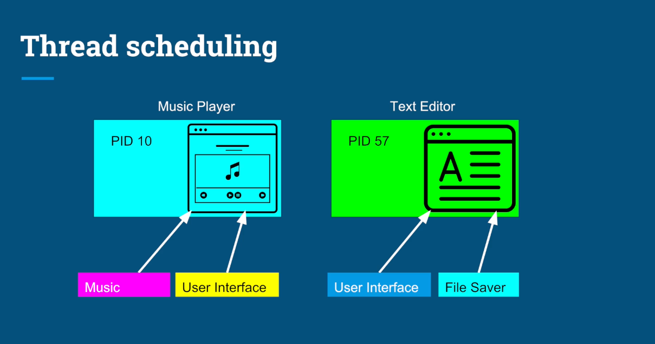

So for simplicity, we also have one core and we have four threads.

We need to decide how to schedule on that one core.

So assuming the arrival or their, of their tasks and their corresponding

length of execution is given how does the operating system decide who runs first?

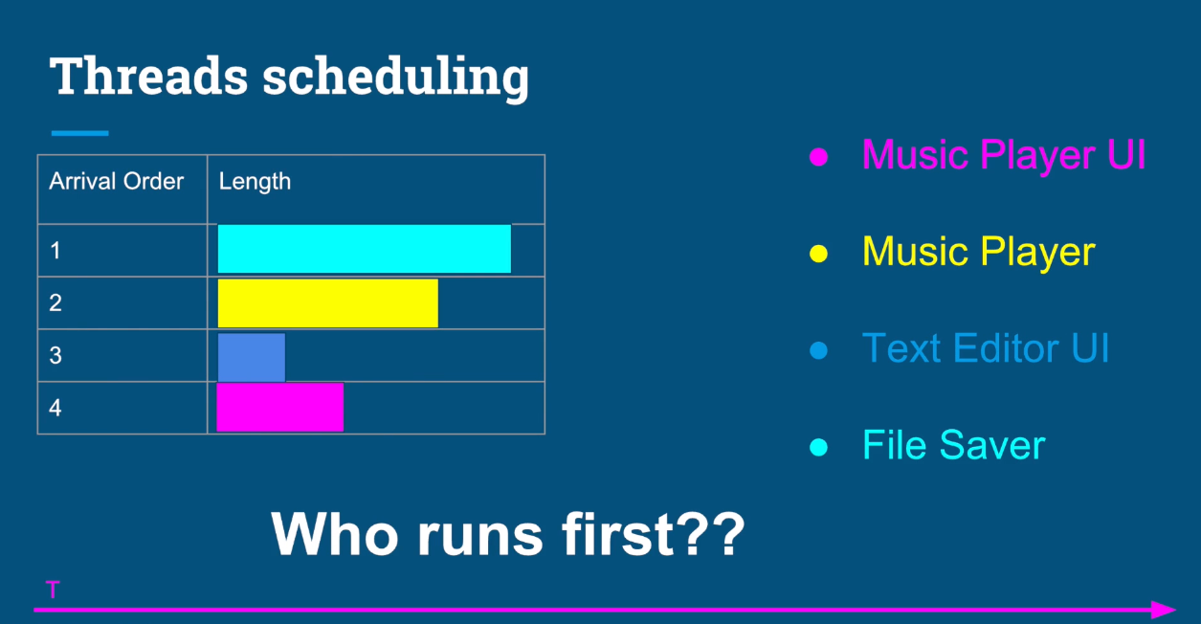

So how about we simply schedule the tasks on the first come first serve basis.

That sounds fair.

Whoever came first should be executed first.

So we scheduled the file saver thread first, then the music player thread,

the text editor, UI thread, and the music player, UI thread in the end.

The obvious problem with this approach is if a very long thread

arrives first, it can cause what's called starvation for other threads.

This is a particularly big problem for you.

I threads this will make our applications unresponsive and our

users will have a terrible experience.

A common fact that you might've already noticed in the table is

that UI threads are usually shorter.

Normally they simply respond to an input from a user and update the screen.

So how about we schedule a shorter job first in this case, our scheduling

sequence would look like this.

However, this has an opposite problem.

There are user related events coming to our system all the time.

So if we keep scheduling the shortest job first, all the time,

the longer tasks that involve computations will never be executed.

Okay.

So now after we ran those thought experiments and understand what kind

of trade offs and challenges the operating system needs to deal with

when fairly allocating the CPU time among threads, let's learn how itreally works in most operating systems.

the operating system divides the time into moderately

sized pieces called epochs.

In each epoch, the operating system allocates a different

time slice for each thread. Notice that not all the threads get to run or complete in each epoch.

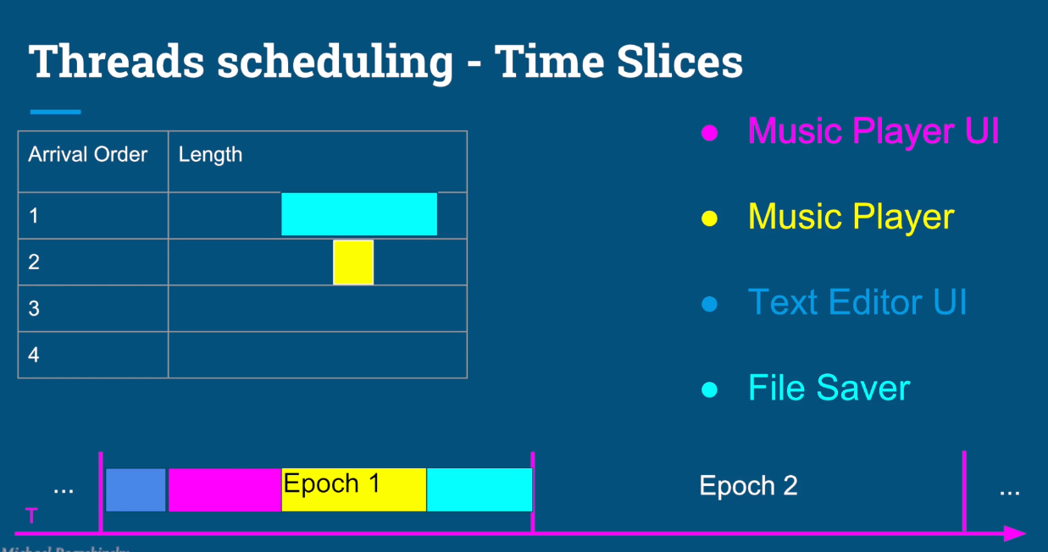

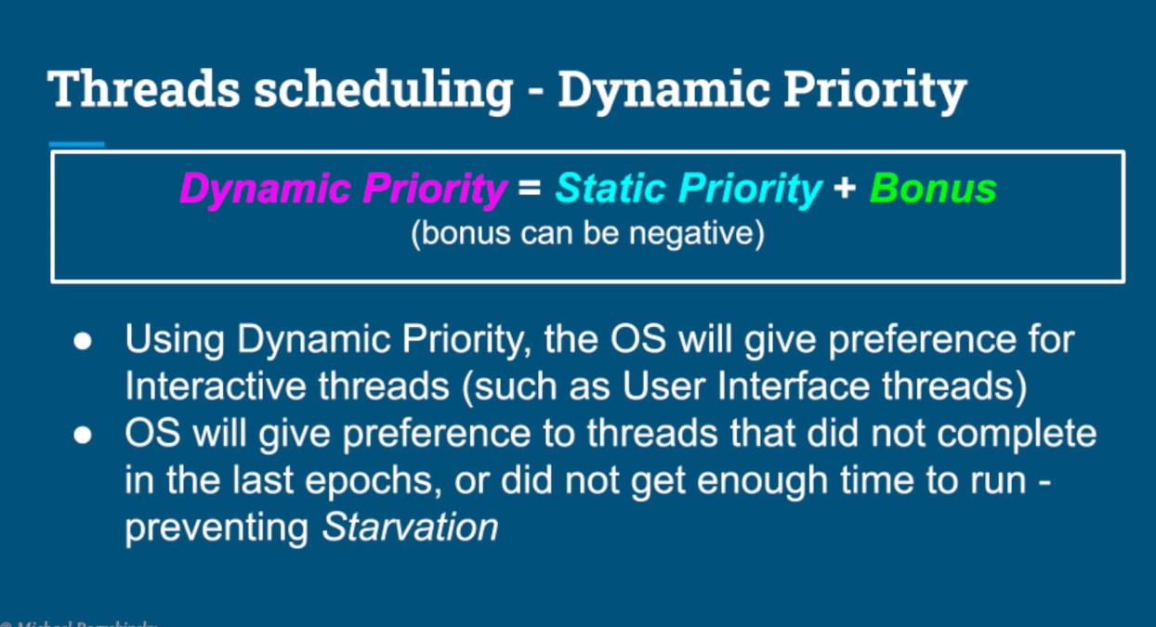

The decision on how to allocate the time for each thread is

based on a dynamic priority the operating system maintains for each thread.

The static priority is set by the developer ahead of time.

And the bonus is adjusted by the operating system.

In every epoch,for each thread, this way the operating system will give preference

to interactive and real time threads that need more immediate attention.

And in the same time, it will give preference to computational threads

that did not complete, or did not get enough time to run in previous epoch to prevent starvation.

#### When to use multiple threads in a single program? And when to simply create a new program and run in a different process?

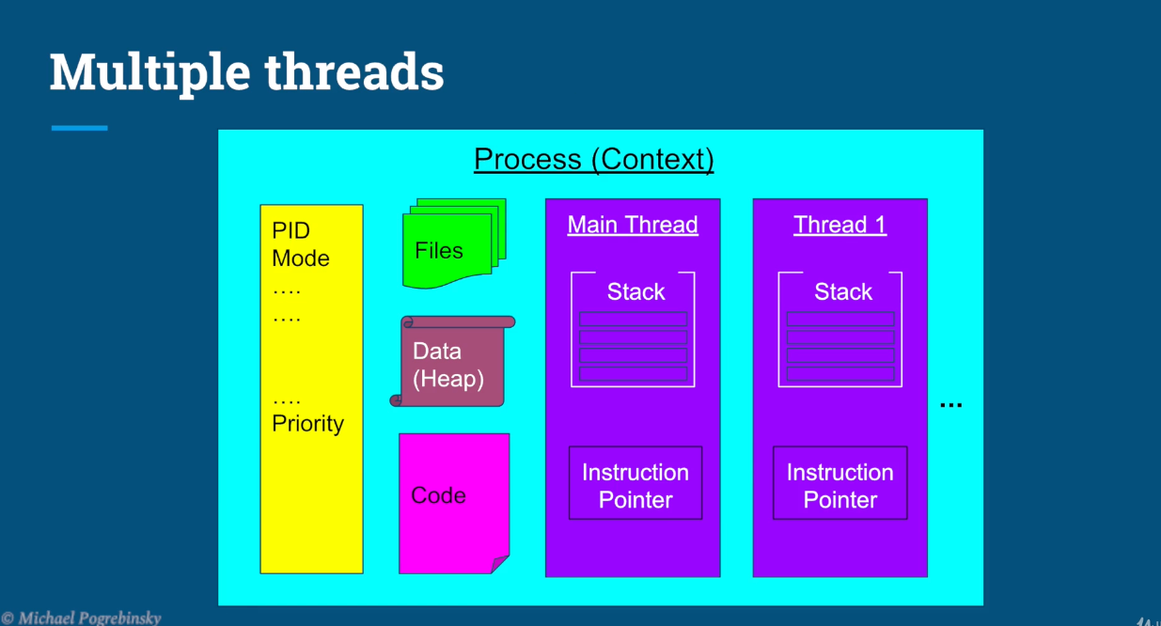

#### VS

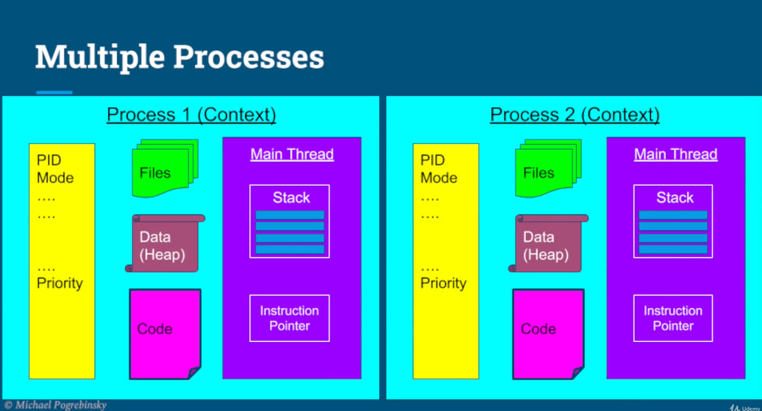

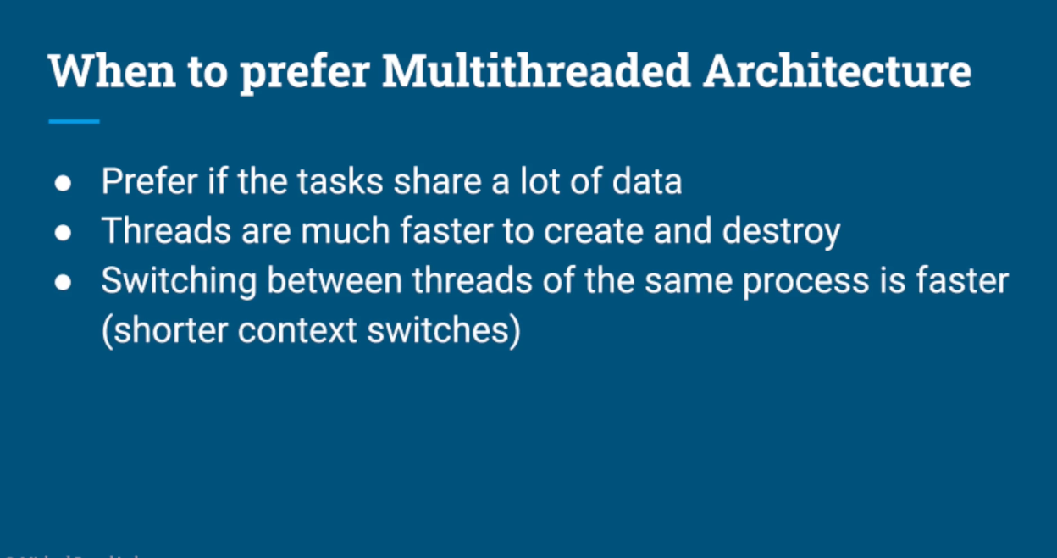

# VS

